Reverse 2: Funmail 1

The description says:

*"One of our employees has locked himself out of his account. can you help 'john galt' recover his password? And no snooping around his emails you hear.”*

John Galt lost his password and we need to recover it. We can start by executing the program:

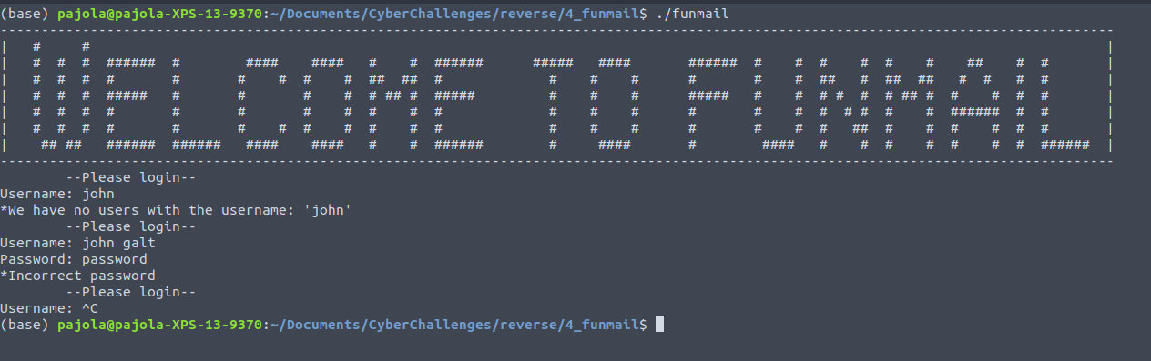

It is just a problem of finding a proper password … or at least it seems. So far we saw three tools that can help us with reversing tasks:

* Objdump
* Strings
* IDA

In this case we can use *strings*, and look if the password is saved inside the object.

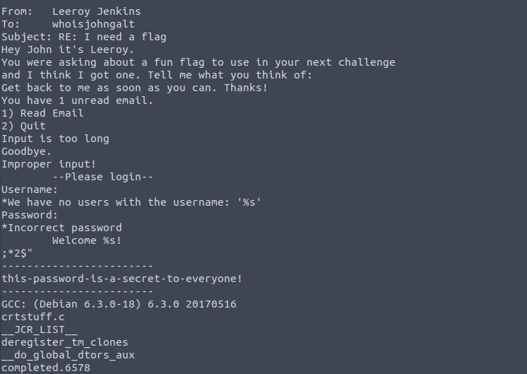

“this-password-is-a-secret-to-everyone!” … well … I guess this is all.

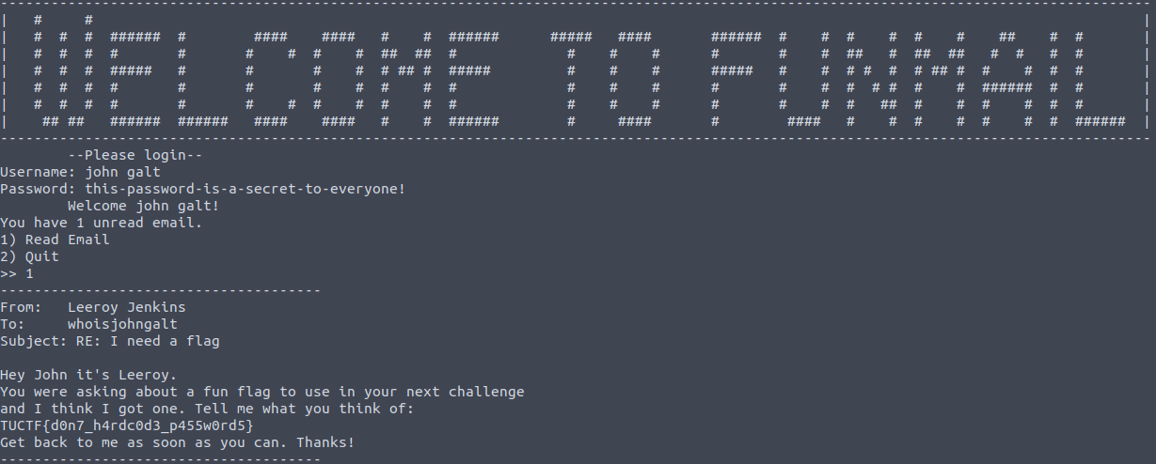

And the flag is captured. TUCTF{d0n7_h4rdc0d3_p455w0rd5}